|  |  |
| --- | --- |
| **GUIDANCE FOR USING THE CAPMANEX TOOL** |  |
| delia Sanchez Trancon and Julia boulenouar |  |
| May 2020 – Version 2 |  |

Note: This guidance assumes that the reader has an existing understanding of life cycle costs; the elements of an asset registry and of the process of developing a WASH investment plan. For more information, please refer to Guidance for assessing piped based water schemes and the Guidance for Developing a WASH investment plan.

Capital Maintenance Expenditure (or CapManEx) is defined as the occasional cost of repairing the components of a water scheme to ensure that services continue at the same level of performance that was first delivered. It is based on the age and the physical state of the components. For example, replacing an engine on a power pump, cleaning a water tank, etc. (Franceys & Pezon, 2010). The acronym is used throughout this document.

Contents

What is the Objective of the CapManEx Tool? 5

Underlying principles 5

Overview of the CapManEx Tool structure 5

What is needed before calculating the CapManEx? 7

How to calculate the CapManEx needed at the district-level? 9

How to add new schemes? 9

How to add new costs criteria within existing components? 10

Including costs for a “simple component” 10

With criteria already indicated in the tool 10

Without criteria indicated yet in the tool 11

Including costs for a “complex component” 12

How to include an additional component which already exists in the tool? 15

How to include a new component which does not exist in the tool? 17

What are the limits of the CapManEx tool? 18

Annex 1:Description of “the overview of investment needed” tab 20

Annex 2: Bibliography 24

**Background**

The District-Wide Approach (DWA) is a global initiative, which seeks to support the achievement of universal and sustainable access to services, by strengthening the enabling environment, with a focus on the district, as the service authority.

As part of the DWA in Rwanda, districts are supported in their efforts to develop WASH investment plans. The key steps required to develop such plans are summarised in figure 1 below, on the left-hand-side of the figure. For each step, a series of tools have been identified to support the district in the collection and analysis of data.

The CapManEx tool is part of this suite of tools, which seek to i) calculate the capital replacement costs of existing services and ii) feed into the broader cost calculations required to achieve the district’s vision of achieving universal and sustainable services.

**Figure 1: Process for developing a WASH investment plan**



Tools available to support the generation of these outputs are presented in the Guidance for Developing a WASH investment plan and briefly presented below:

* Step 1: Identify status of current services provision:
  + The Asset registry aims to identify, catalog and classify all water schemes within a district, based on their current needs and general timeline for potential repair and/or replacement of significant components;
  + Service level assessments, indicate the level of service according to national norms at the level of water point;
  + The District capacity assessment tool provides a quantitative assessment of the extent to which financial and human resources are in place at local government level to fulfil all their service authority functions adequately.
* Step 3: Estimate costs of achieving and sustaining the vision (CapEx, CapManEx and DSexp)
  + AtWhatCost supports the identification of current costs of maintaining services and projects profitability of a given scheme/service provider. This tool can be used to set tariffs and to check affordability levels both for the district as well as the services providers. It is currently being tested to determine the “ideal” level of direct support provided by the district.
  + CapManEx tool: estimates the CapManEx requirements to maintain existing services over a 10- year period. The present guidance note presents the tool and the process for using it.
  + Several approaches can be used to calculate CapEx: i) detailed engineering designs for the entire district to identify accurate costs of building new schemes, ii) national unit costs/ person to estimate the cost of building new schemes, iii) combined detailed engineering designs on a sample of schemes to derive customised unit costs for building schemes across the district;
* Step 4 and 5: Financial modelling:
  + The financial Overview tool is currently under development and will combine the projections of the needs (i.e. the outcomes of each of the tools), and the sources of finance in relation to the district’s budget.

This document is designed for entities providing support to the districts and describes step by step, how the information contained in the asset registry should be converted into a projection of CapManEx over time.

# What is the Objective of the CapManEx Tool?

This tool provides a calculation of the CapManEx required every year to maintain existing services, based on the i) age of the component and ii) its physical condition. All estimates are based on the current state of assets, as indicated in the asset registry and are spread over ten years.

# Underlying principles

* It uses asset registry as the entry point to determine the CapManEx required based on two parameters: i) the asset components’ age and the asset components’ condition (or physical state);
* CapManEx based on age are spread over time using the remaining design lifetime of each asset component as a basis;
* CapManEx costs based on the physical state are spread over time based on the high, medium or low priority to repair or replace the components defined in the asset registry. The estimated costs are spread over time with the assumption that high priority repairs should take place in the coming 3 years, medium priority repairs between 4 and 5 years and low priority repairs between 6 and 10 years.
* CapManEx costs based on the physical state and the remaining life are combined and costs identified beyond the 10-year threshold ignored;
* This tool has been designed to support districts in Rwanda. For that reason, minor repair (or OpEx), which fall outside of the District’s responsibility are calculated but not used in the CapManEx tool. If used in a different context the OpEx could be taken into consideration, but this would require to modifications to the tool.

# Overview of the CapManEx Tool structure

The tool is excel-based. Because, its calculation uses the asset registry as a basis it is recommended to add the tab corresponding to the CapManEx tool to the existing asset registry excel document and to link it to the needed cells.

It is structured in such a way to first allow for a calculation of CapManEx based on age and condition (or “physical state”) per scheme, before aggregating the costs into an overall CapManEx cost, spread over time.

* **Raw data – water points** tab contains the data collected during the asset inventory which has not yet been cleaned and organised per water scheme.
* **Raw data – schemes** tab contains the data collected during the asset inventory. The level of analysis is the water scheme, meaning one row should contain all the information pertaining to one water scheme;
* **ComponentCostCalculation** tab contains the raw data collected during the asset inventory and additional columns for each component:
  + Remaining life of component
  + Cost of the remaining life of this component
  + Cost of this material (based on its physical state)
* **Overview of investment needed**: shows an overview of the CapManEx needed over time. Users can find three graphs under this tab (for more visual information, please see annex 1):
  + **Overview of the investment needed for CapManEx based on physical state**

This graph represents the CapManEx based on the physical state of all the components for all schemes. When the physical state of a component is considered “poor” or “does not function” and falls under the category of CapManEx, the tool considers the cost of major repair or construction/replacement respectively. For specific details about each one of the components, please see the tab CapManEx categories[1].

The total CapManEx based on the physical state is spread over ten years. The division between the years in done based on the level of priority to replace/repair the scheme provided in the Asset Registry tab (high= 6-10 years; medium =4- 5 years and low = 3 or less years). This time division can be modified, by changing the years on top of the table (dark pink row) and therefore, the spread over time.

* + **Overview of the investment needed for CapManEx based on remaining useful time**

This graph represents the CapManEx based on the remaining life of all the components for all schemes up to ten years.

When the physical state of a component is considered “normal”, the tool considers the cost of construction/replacement for that component and projects it into the corresponding year of replacement. The reference design lifetime information is obtained through the Reference sheet tab.

Over ten years period the CapManEx cost is not presented. However, if needed it can be done by extending the years columns and dragging the formula from the current tabs.

* + **Overview of the investment needed for CapManEx**

This graph presents the aggregation of the CapManEx based on the physical state and the age of all the components for all schemes over a ten years period.

This graph in connected to a table that summarizes the total cost of CapManEx per year for all schemes.

* + **Summary table - Overview of the global CapManEx (columns BT to CE)**

The table summarises key information per scheme such as: the name of the scheme, the population using this scheme, the year of the construction, the risk scheme risk based on its conditions, the timeframe for repairing component, the components needing a major repair or replacement/construction and the CapManEx needed based on the physical state. In addition, this table shows the CapManEx based on the remaining life per scheme and per year, and the total per year.

Under the column named Components needing CapManEx information is provided on the components which have a poor or does not function physical condition for each scheme. When updating the physical state of each component per scheme, this column will automatically update itself.

* **CostReference** presents several tables of costs of minor repair, major repair and construction/replacement per type of component and component features (e.g. size, length, material). The following component information are provided:
* Conduction line
* Storage tank on stone masonery
* Storage tank concrete
* Intake structure on stone masonery
* Distribution network
* Pump
* Pump housing
* Treatment equipment
* Treatment housing
* Kiosk
* Water stand
* Air vent chamber
* Washout chamber
* Break pressure chamber
* Collection chamber
* Selection chamber
* Valve chamber

Please check that the schemes have exactly the same type of component and the characteristic presented in the CostReferencesheet tab. If it is not the case, the tab and consequently, the formulas would need to be modified in order to calculate the CapManEx. This should be done by somebody with advance excel skills.

This cost reference sheet is used as a basis for calculating the CapManEx based on the physical condition of the components.

The cost inputted in the table can be modified directly. If users require to add new components or new criteria, they should follow the instructions in the relevant sections of this document.

* **LifetimeReference tab** contains the design lifetime reference for each one of the components. Please check that the schemes have exactly the same type of component presented in the LifetimeReferencesheet tab. If it is not the case, the tab and the formulas would need to be modified in order to calculate the CapManEx. This should be done by somebody with advance excel skills.
* **CapManEx categories** present for each type of component in a water scheme, what is defined as normal, poor and does not function physical state and provides its corresponding category in the life cycle cost (OpEx and CapManEx). These definitions come from the “Guidance for assessing piped based water schemes” developed for WaterforPeople and correspond to the specific case of responsibility division between the district and the service providers in Rwanda. The formulas in the ComponentCostCalculation and Overview of investment needed are based on it. If these categories do not correspond to your context, the formulas should be modified in the Overview of investment needed tab. More specifically, in the summary tab, in the column CapManEx based on the physical state.

# What is needed before calculating the CapManEx?

Important note: Excel makes the difference between " and “ therefore, users should verified that their keyboards allow them to put the right symbol ".

* **Asset registry completed:** the CapManEx calculations are based on the information presented in the Raw Data -schemes tab. To find more information on how to fill it, please see the document named “Guidance for assessing piped based water schemes” more details in Annex 2.
* **Filling the CostReferencesheet:** the CapManEx cost are based on this tab. This tab needs to be filled in to obtain the CapManEx cost.
* **Connecting the Raw Data- schemes tab and ComponentCostCal tab**: all cells in the Raw data -schemes tab should be connected to the ComponentCostCal. Only the columns “Remaining life of XX”, “Cost of XX “and “Cost of the remaining life of XX” in the ComponentCostCal are not connected to the Raw Data tab. These columns contained results based on formulas. This may be done manually for the first row and extended for the following.
* **Adapting the ComponentCostCal tab:** if for a specific component more units that the ones presented in the ComponentCostCal exist, the following additional columns will need to be inserted (“physical state”, “material”, “number”, “cost of XX” and “cost of the remaining life XX”). For example, the water scheme has more than 2 intake structures, users can add additional columns. It is important to keep in mind that Excel can manage a limited number of data points and formulas, therefore this tool may not be adapted for a very complex urban water scheme.

“Physical state”, “material” and “number” should be copied and pasted from the Raw Data tab. For “cost of XX” and “cost of the remaining life XX”, these columns should be copied and pasted from the ComponentCostCal tab.

For modifying the formula, double click on the cell and drag the cells selection until they correspond to the different cells needed to calculate the cost of the component.

It is important to note, that if one of the categories is empty or missing, the calculation will not function. In cases where information about the size, number and condition of the components is available but the year of construction is not provided, the year of construction should be collected.

The new costs columns “Cost of the new type component 1” and “Cost of the remaining life of new type component 1” in the CostCalculation tab are not automatically taken into account in the Overview tab by the tool. The user needs to follow these steps to include them:

1. For the CapManEx related to physical state – column T

The formula follows this logic : =+SUMIF(ComponentCostCalc!AT3,@{"Poor";"Does not function"},ComponentCostCalc!AW3), which means =SUMIF(physical state of the component equals {"Poor";"Does not function"},the take into account cost of the component based on its physical state)

The user should modify the pink section to correspond to the new cost columns inputted. The formula should be added to the already existing SUMIF included.

Drag down the cell to include it for the whole column.

1. For the components needing repair – column S

The formula follows this logic: (IF(OR(ComponentCostCalc!AT2="Poor",ComponentCostCalc!AT2="Does not function"),"New component1; ",""), which means that the formula will indicate the name of the component it it is in a poor or does not function condition.

The user should modify the pink section to correspond to the new cost columns inputted. The formula should be added to the already existing IF(OR formula

1. For the CapManEx related to the age of the component – columns V to AF

It follows the same logic that CapManEx cost related to physical state, however, in this case, the year condition needs to be included. It has been already included in the formula, so the users do not require to do it.

The formula follows this logic: (IF((ComponentCostCalc!$AS2+ComponentCostCalc!$I$2)=$V$1,ComponentCostCalc!$AX2,"0"))

The user should modify the pink section to correspond to the new cost columns inputted. The formula should be added to the already existing IF included.

Drag down the cell to include it for the whole column.

This step needs to be repeated for all columns from V to AF

1. For the components needing replacement – columns AH to AR

The formula follows this logic: (IF(AND(ComponentCostCalc!AS2=$W$1-$V$1,ComponentCostCalc!AT2="Normal"),"New component 1”; ","")

The user should modify the pink section to correspond to the new cost columns inputted. The formula should be added to the already existing IF included.

Drag down the cell to include it for the whole column.

This step needs to be repeated for all columns from AH to AR

# How to calculate the CapManEx needed at the district-level?

1. Collect all the information needed to fill the Raw Data tab and asset registry tab for all the schemes. Users may need detailed engineering plans;
2. Adapt if needed, the lifetimes and component list in the LifetimeReference Sheet
3. Adapt if needed the CostReferencesheet to the components of the scheme
4. Fill the CostReferencesheet for all the unit cost of the component present in the schemes.
5. Connect the Raw Data and the ComponentCostCal
6. The cost per component will be calculated automatically
7. The tab named overview of investment needed will present the CapManEx cost over the years

# How to add new schemes?

As long as the new schemes contain the same type of component, they can be added to the CapManEx tool. The same steps as presented in how to calculate the CapManEx paragraph needs to be done. In addition, drag the columns with the formulas, to obtain the CapManEx cost calculation.

In the case where there is no modification on the overview of investment needed tab please check that the different tables consider the news schemes. To do so, just drag down the formula in the summary tab.

* For the CapManEx based on the physical state, check that the table considers the new schemes. If not, just add them in manually by dragging down the last row between columns H and T. To see the formula double click on the cell (columns H to T).

Schemes priority – column Q

High priority will correspond to schemes that need to be repaired or replaced in less than three years, medium priority to those needing repair/replacement in less than five years and low priority in less than ten years. This is set up based on the formula in column QT in the Raw Data -schemes tab. For more details, please refer to the formula directly.

Table between columns B to D

The formulas are developed as follow:

* + For three years - Sum if the level of priority to replace/repair is “High priority”, the cost of the CapManEx based on the physical state for Scheme A + Sum if the level of priority to replace/repair is “High priority”, the cost of the CapManEx based on the physical state for Scheme B + etc. The resulting cost is spread over years one to three.
  + For five years - Sum if the level of priority to replace/repair is “Medium priority”, the cost of the CapManEx based on the physical state for Scheme A + Sum if the level of priority to replace/repair is “Medium priority”, the cost of the CapManEx based on the physical state for Scheme B + etc. The resulting cost is spread between years four and five.
  + For ten years - Sum if the level of priority to replace/repair is “Low priority”, the cost of the CapManEx based on the physical state for Scheme A + Sum if the level of priority to replace/repair is “Low priority”, the cost of the CapManEx based on the physical state for Scheme B + etc. The resulting cost is spread between years six and ten.

If a new row is added after scheme number 127, within the formulas in column B to D, the user should have to include the new scheme.

Any other time scale can be selected by modifying the row under years in the table linked to the graph (cells B2, C2 and D2).

For example, instead of having the high priority schemes set for three years, the medium priority schemes for five years and the low priority schemes for ten years, it could be modified to one, three and five years depending on the revenue flows of the district. To modify it, just change the number of years in the CapManEx based on physical state table, the table under it which spread the cost over 10 years and the graph will automatically change.

* For the CapManEx based on remaining life table, check that the table takes into account the new schemes. If not, please add rows between the last row of the table and the final row containing the addition of all rows in the table. And, then drag the formula. Please, verify that the last row adds the new schemes in.
* For the CapManEx table, it should be done automatically when modifying the other two tables. If not, please check that the correct cells are taken into account for the table.

# How to add new costs criteria within existing components?

Users can include new unit costs for each component, if some of the components’ features were not included in the initial design of the CapManEx tool. For example, if a water scheme has a storage tank with a head size that was not originally included in the CapManEx tool.

The following sections describe how new information about components can be added to the tool. Components can be divided between simple components and complex components. The costs of “simple components” are only defined by one criterion, such as a storage tank, the cost of which is defined based on the size. The costs of “complex components” are defined by at least two criteria. For example, the cost of a pipe is defined based on the material, nominal diameter and nominal pressure.

When only adding new criteria in the existing components, the tool will take into account the new cost automatically in the Overview tab. So, no modification is required in the Overview tab.

## Including costs for a “simple component”

For components with only one criterion defining their price, the user only has to introduce the new information and the associated prices. Additional rows have already been included in the CostReference tab, and the formulas have been modified to automatically take into account new data inputted.

### With criteria already indicated in the tool

This is applicable for intake structure and pump components.

For example, a water scheme has a pump with a head that has a capacity of 800 m, which is currently not included in the CapManEx. Figure 1 presents the CostReference table for pump costs currently in the CapManEx tool. Figure 2 illustrates an example where a new criterion for pumps needs to be included.

Figure 1: Original image of the CostReference table

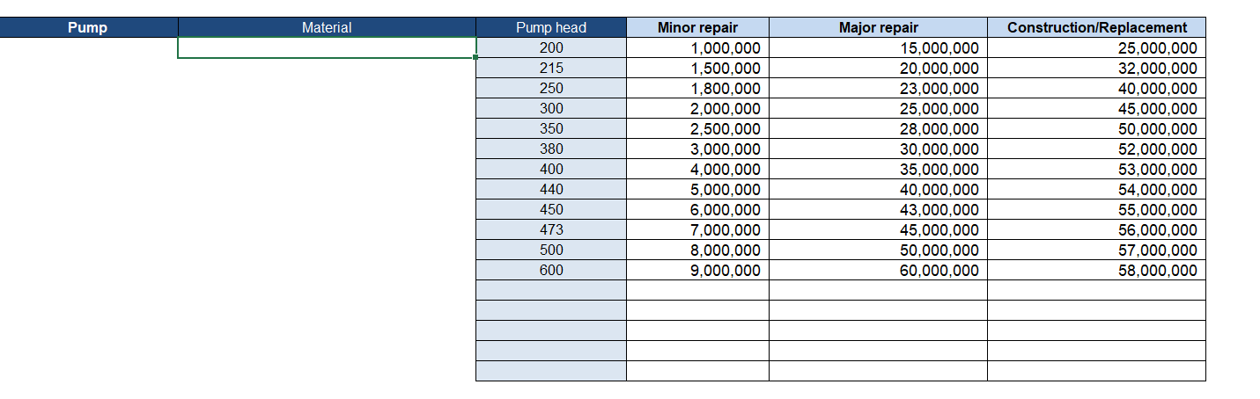

Figure 2: Example of data inputted in the CostReference tab for a simple component

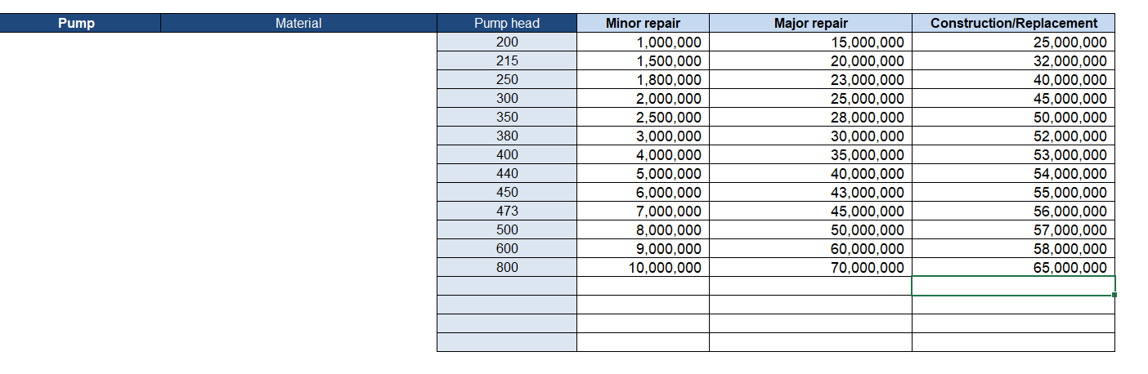

### Without criteria indicated yet in the tool

This is applicable for intake structure, pump housing, treatment equipment, treatment house, kiosk, public stand and other concrete structure components.

When the tool was developed these components only had one criterion. If new criteria need to be added per component, the user should follow these steps:

1. Add a new column in the raw data tab (as well as a new question in the survey) to indicate the new material/size of the component
2. Add a new column in CompostComponentCalculation tab and link it to the raw data tab. For that, the user will need to select the first cell of the column, and insert “= and click on the first cell of the column in the raw data tab”, then the user should drag down the column, to link the whole column.
3. Add in the CostReference tab the new cost and criteria for the component
4. The current formula for the CapManEx of the simple component has to be modified to adapt to the new criteria. For that, the IF formula should be modified in a VLOOKUP formula. Let’s take the intake structure component as an example:

Currently, the formula is “=IF(AT2 ="Normal", ((CostReferenceSheet!$C$54)*AV2), IF(ComponentCostCalc!AT2="Poor", ((CostReferenceSheet!$D$54)*AV2), IF(ComponentCostCalc!AT2="Does not function", ((CostReferenceSheet!$E$54)*AV2), "Error")))”

Depending on the new criteria (material or size) the formula should follow this logic:

=IF(AT2="Normal",(VLOOKUP(**UO2**,CostReferenceSheet!$B$**53:$E$57**,2,FALSE)*AV2),IF(AT2="Poor",(VLOOKUP(UO2,CostReferenceSheet!$**B$53:$E$57**,3,FALSE)*AV2),IF(UN2="Does not function",(VLOOKUP(UO2,CostReferenceSheet!$ **B$53:$E$57**,4,FALSE)* AV2),"")))

UO2 – correspond to the cell where the new criteria (material or size) is indicated. It is required to have the exact spelling that in the CostReference tab. If not the formula would not work.

CostReferenceSheet!$B$**53:$E$57** – correspond to the table where the formula is going to look for the new criteria. Please do verify for each component the length of the table before inputting the formula. For example, for the pump housing, it is CostReferenceSheet!$**C$107:$F$111**

AV2- do not forget to multiple it by the number of components which have that characteristic.

1. Drag down the formula down the column to ensure all schemes are taken into account.
2. Do the same in the column for cost calculation based on the physical state. Currently, it is =IF(AT2="Normal",((CostReferenceSheet!$E$54)*AV2),"0")

Please follow step 4 again for this column: =IF(AT2="Normal",(VLOOKUP(**UO2**,CostReferenceSheet!$B$**53:$E$57**,2,FALSE)*AV2)

U02 – referring to the new material or size included.

1. If more than three new additional criteria are required, the user will need to add a row in the CostReference tab, as well as modified the table length when inputting the formula for cost calculation. It is important to keep in mind that Excel can handle a maximum number of data points and combinations. If many new criteria are required, it may be needed to use a software specialised in CapManEx calculations.

## Including costs for a “complex component”

This applicable for components with multiple criteria such as pipes (distribution network and conduction line), where several cases exist.

Pipes’ components are used to illustrate how to modify the formulas in the CapManEx tool to include the new unit costs.

* **A new pipe that only has a different characteristic (for example nominal diameter 500)**

1. Go to the CostReference tab and insert a new row under the last row of the table.

Figure 3: Original Costreference table for conduction line components

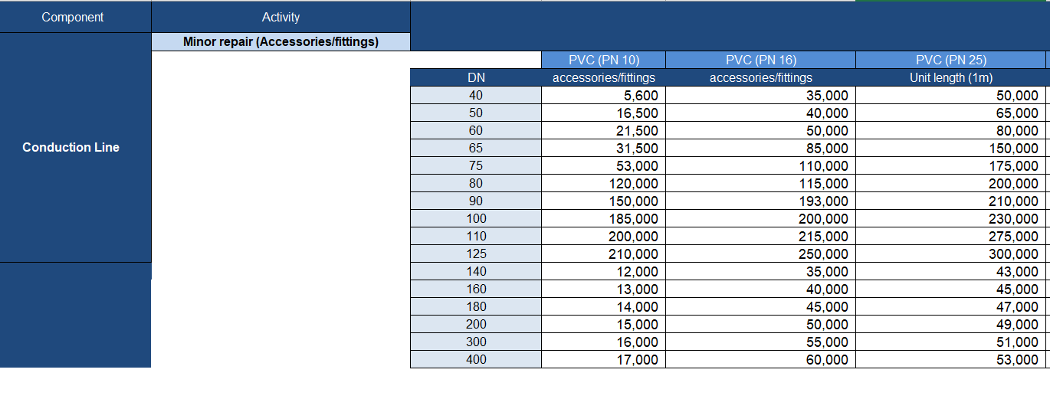

Figure 4: Example of data inputted in the CostReference tab for a conduction line with a new nominal diameter (DN)

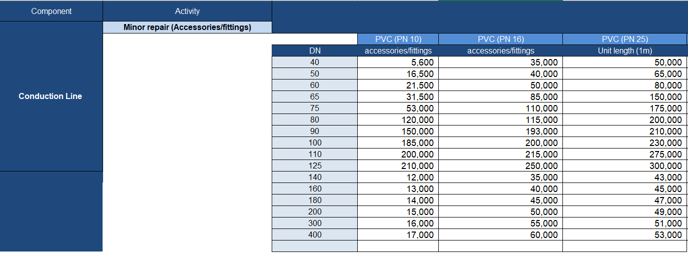

1. Go to the ComponentCostCalculation tab and look for the first column containing information for the cost calculation of the conduction line (column BT).
2. Click on the first cell, which contains the formula for calculating the cost. The formula will appear.

Figure 5: Screenshot from the ComponentCostCalulation tab, while clicking on column BT

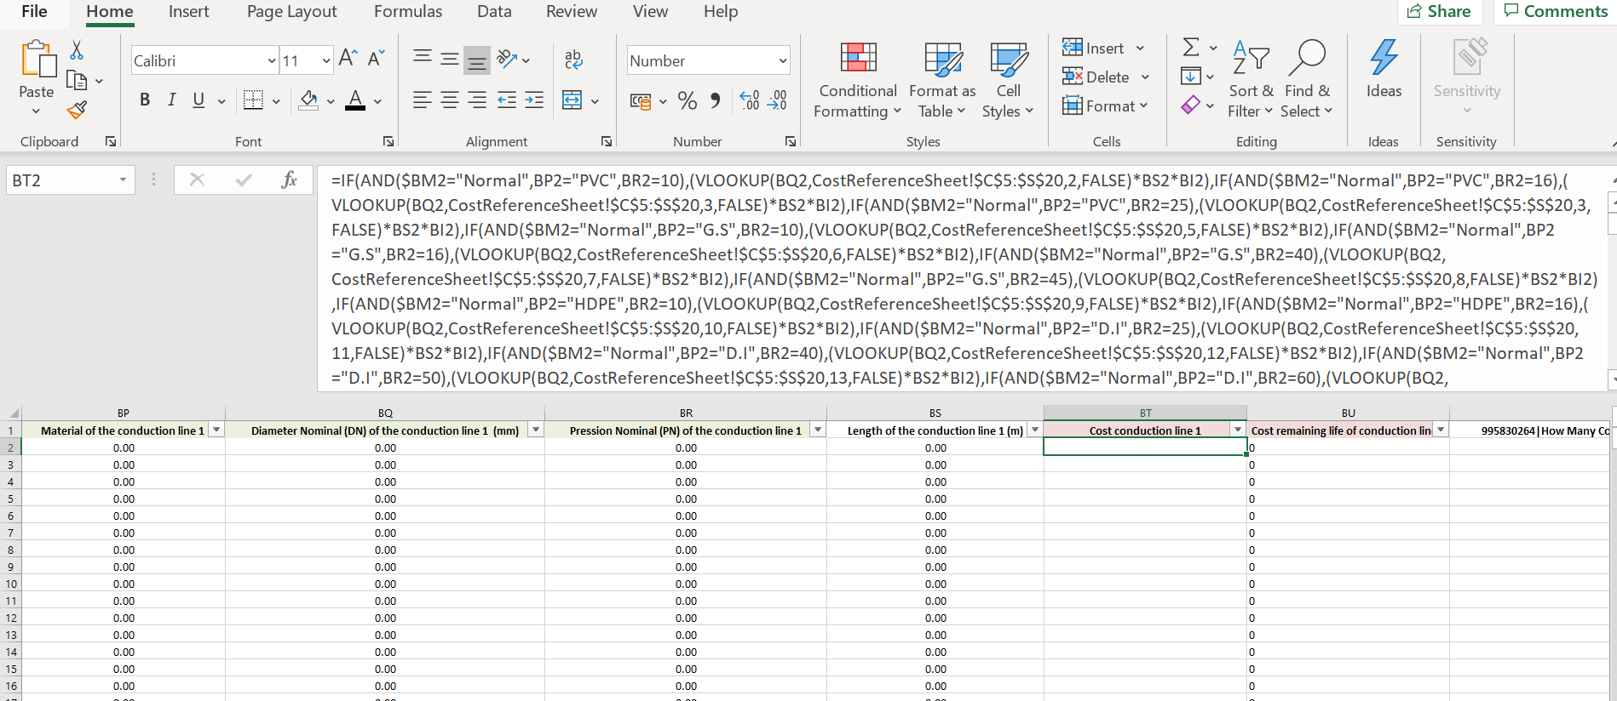

1. Modify the formula to allow the VLOOKUP function to include the new cost. For that, the user will need to change all VLOOKUP functions in the formulas, from VLOOKUP(BQ2,CostReferenceSheet!$C$5:$S$20,2,FALSE) to VLOOKUP(BQ2,CostReferenceSheet!$C$5:$S$**21**,2,FALSE) because a new row was included. If several rows were included, then the VLOOKUP function will have to reach until the last row included. After modifying all VLOOKUP functions, click enter.
2. Drag down the corner of the modified cell to modify all the cells in column BT of the ComponentCostCalculation tab.
3. Repeat the same procedure on column BU.
4. Repeat the same procedure in other columns for calculating pump costs. Copy-paste the new formula to the other cells, but it is important to be careful that the formula takes into account the characteristics of the other component (the next pump) and not the previous one (the first pump, where the formula was modified).

* **A new pipe that only has two different characteristics (for example, G.S material and nominal pressure 10).**

1. Go to the CostReference tab and insert a new column after the last column of the table.

Figure 6: Original CostReference table for conduction line components

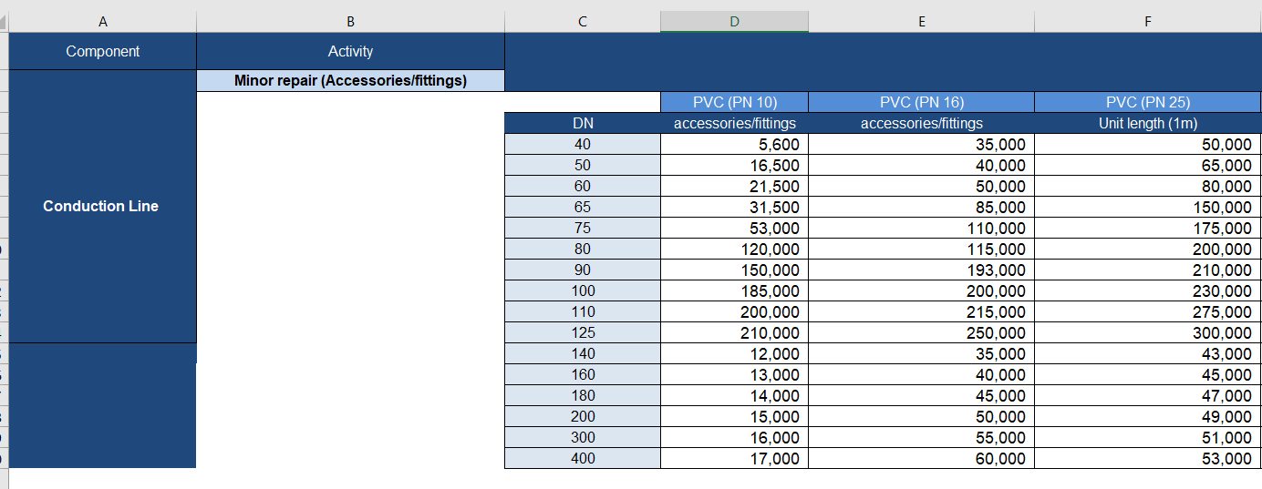

Figure 7: Example of data inputted in the CostReference tab for a conduction line with new material and nominal pressure (PN)

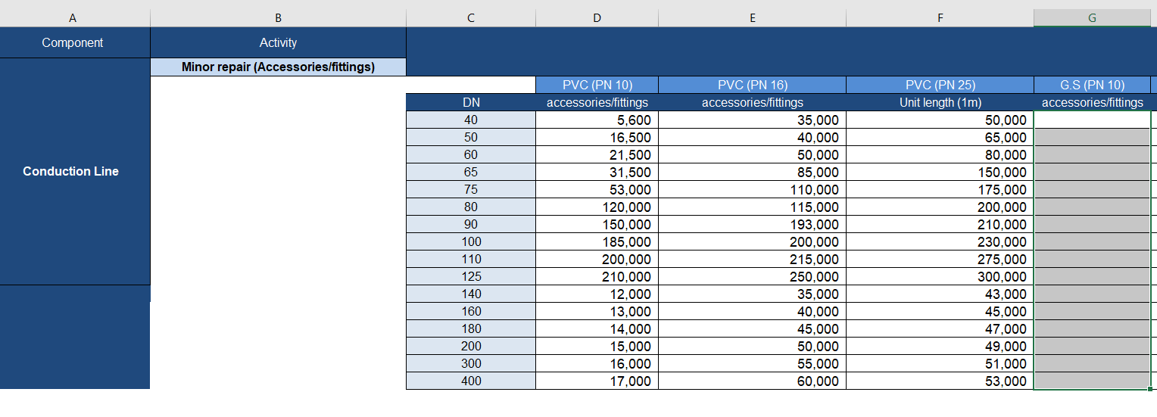

1. Go to the ComponentCostCalculation tab and look for the first column containing information for the cost calculation of the conduction line (column BT).
2. Click on the first cell that contains the formula for calculating the cost. The formula will appear.

Figure 8: Screenshot from ComponentCostCalulation tab, while clicking on column BT



1. Modify the formula to include the new material and allow the VLOOKUP function to include the pressure. For that, the user will need to add the following information in the formula as shown in Table 1.

By changing CostReferenceSheet!$C$5:$S$20 to CostReferenceSheet!$C$5:$T$20 , the user is allowing VLOOKUP to take into account the new column. By including IF(AND($BM2="Normal", **AS2="G.S",AU2=10**),

(VLOOKUP(AT2,,CostReferenceSheet!$C$5:$**T**$23,**5**,FALSE)* AV2*AO2) , the user is allowing the formula to take into account the new material G.S and its associated pressure.Then, the user should include for major repair and replacement, following the same logic

IF(AND(OR($AR2="Poor",$AR2="Does not function"),**AS2**="G.S",**AU2**=10),

(VLOOKUP(AT2,CostReference!$W$5:$**AN**$23,**5**,FALSE)*AV2*AO2),

After modifying all VLOOKUP functions, click enter.

Table 1: Example of modifications in the formula to take into account new material and nominal pressure

|  |  |
| --- | --- |
| Original formula (simplified example) | Formula modified to include the new material |
| =IF(AND($BM2="Normal",BP2="PVC",BR2=10),(VLOOKUP(BQ2,CostReferenceSheet!$C$5:$S$20,2,FALSE)*BS2*BI2),IF(AND($BM2="Normal",BP2="PVC",BR2=16),(VLOOKUP(BQ2,CostReferenceSheet!$C$5:$S$20,3,FALSE)*BS2*BI2),IF(AND($BM2="Normal",BP2="PVC",BR2=25),(VLOOKUP(BQ2,CostReferenceSheet!$C$5:$S$20,4,FALSE)*BS2*BI2),””))))) | =IF(AND($BM2="Normal",BP2="PVC",BR2=10),(VLOOKUP(BQ2,CostReferenceSheet!$C$5:$**T** $20,2,FALSE)*BS2*BI2),IF(AND($BM2="Normal",BP2="PVC",BR2=16),(VLOOKUP(BQ2,CostReferenceSheet!$C$5:$**T** $20,3,FALSE)*BS2*BI2),IF(AND($BM2="Normal",BP2="PVC",BR2=25),(VLOOKUP(BQ2,CostReferenceSheet!$C$5:$**T** $20,4,FALSE)*BS2*BI2),IF(AND($BM2="Normal",**BP2="G.S",BR2=10**),(VLOOKUP(BQ2,CostReferenceSheet!$C$5:$**T**$20,**5**,FALSE)*BS2*BI2),””))))))) |
| IF(AND(OR($AR2="Poor",$AR2="Does not function"),AS2="G.S",AU2=10),(VLOOKUP(AT2,CostReference!$W$5:$AM$23,5,FALSE)*AV2*AO2) | IF(AND(OR($AR2="Poor",$AR2="Does not function"),AS2="G.S",AU2=10),(VLOOKUP(AT2,CostReference!$W$5:$**AN**$23,**5**,FALSE)*AV2*AO2) |

The same command has to be done for repair and replacement at the end of the formula

1. Drag the corner of the modified cell down to modify all the cells in column BT of the ComponentCostCalculation tab.
2. Repeat the same procedure on column BU (CapManEx cost based on the remaining life of the component)
3. Repeat the same procedure in the other columns for calculating pipe costs. Copy-paste the new formula to the other cells, but it is important to be careful that the formula takes into account the characteristic of the other component (the next pump) and not the previous one (the first pump, where the formula was modified).

* **A new pipe that only has three different characteristics (for example, G.S material, nominal pressure 10 and nominal diameter 500).**

Combine the two precious example by including a new row (simple component example) and a new column (complex component example).

# How to include an additional component which already exists in the tool?

If a component is present in a scheme more times than the already indicated in the tool, users can include them. The tool has been designed allowing additional components to be included, most of the time more than 10 variations within the same component. It is important to keep in mind that Excel can manage a limited number of data points and formulas, therefore this tool may not be adapted for a very complex urban water scheme. For example, the water scheme has more than 2 intake structures, users can add additional columns. To do it, users should follow these steps:

1. Add new columns in the raw data tab (as well as a new question in the survey) to indicate the new component as well as its characteristics (size, material, diameter, pressure, etc). For each information, a column should be added (pack columns), depending on the characteristics all points will not be relevant
   1. Year component 12 was Constructed or Last Rehabilitated
   2. Physical State Of component 12
   3. Component 12 size (m^3)
   4. The material of component 12
   5. Number of component 12 or length
   6. Diameter Nominal (DN) of component 12 (mm)
   7. Pressure Nominal (PN) of component 12
   8. Length of component 12

Users should add as many columns packs as component 12 were indicated in the CostRefernce tab. For example, if three types of material were indicated, three packs of columns should be added.

1. Add new columns in CompostComponentCalculation tab and link it to the raw data tab. For that, the user will need to select the first cell of the column, and insert “= and click on the first cell of the column in the raw data tab”, then the user should drag down the column, to link the whole column.
2. Add columns
   1. Cost of the component 12
   2. Cost of the remaining life of component 12
3. Input the formulas for calculating CapManEx – this step requires advanced excel and CapManEx knowledge. The formula is specific to the new component and its characteristic, the other component can be used as examples of the formulas which can be used. See the two previous sections

The new costs columns “Cost of component 12” and “Cost of the remaining life of component 12” in the CostCalculation tab are not automatically taken into account in the Overview tab by the tool. The user needs to follow these steps to include them:

1. For the CapManEx related to physical state – column T

The formula follows this logic : =+SUMIF(ComponentCostCalc!AT3,@{"Poor";"Does not function"},ComponentCostCalc!AW3), which means =SUMIF(physical state of the component equals {"Poor";"Does not function"},the take into account cost of the component based on its physical state)

The user should modify the pink section to correspond to the new cost columns inputted. The formula should be added to the already existing SUMIF included.

Drag down the cell to include it for the whole column.

1. For the components needing repair – column S

The formula follows this logic: (IF(OR(ComponentCostCalc!AT2="Poor",ComponentCostCalc!AT2="Does not function")," component 12; ",""), which means that the formula will indicate the name of the component it it is in a poor or does not function condition.

The user should modify the pink section to correspond to the new cost columns inputted. The formula should be added to the already existing IF(OR formula

1. For the CapManEx related to the age of the component – columns V to AF

It follows the same logic that CapManEx cost related to physical state, however, in this case, the year condition needs to be included. It has been already included in the formula, so the users do not require to do it.

The formula follows this logic: (IF((ComponentCostCalc!$AS2+ComponentCostCalc!$I$2)=$V$1,ComponentCostCalc!$AX2,"0"))

The user should modify the pink section to correspond to the new cost columns inputted. The formula should be added to the already existing IF included.

Drag down the cell to include it for the whole column.

This step needs to be repeated for all columns from V to AF

1. For the components needing replacement – columns AH to AR

The formula follows this logic: (IF(AND(ComponentCostCalc!AS2=$W$1-$V$1,ComponentCostCalc!AT2="Normal")," component 12”; ","")

The user should modify the pink section to correspond to the new cost columns inputted. The formula should be added to the already existing IF included.

Drag down the cell to include it for the whole column.

This step needs to be repeated for all columns from AH to AR

# How to include a new component which does not exist in the tool?

If a new component which has not been inputted in the tool is required, the user should follow the following steps. This requires advance Excel skills. Users should only do it when it is not possible to adapt the already existing components, in terms of price and criteria.

1. In the CostRefence tab from row 150, a specific empty table has been included. Users should modify this table as required to suit the new component, other components can be used as an example.
2. Add new columns in the raw data tab (as well as a new question in the survey) to indicate the new component as well as its characteristics (size, material, diameter, pressure, etc). For each information, a column should be added (pack columns), depending on the characteristics all points will not be relevant
   1. Year new type component 1 Was Constructed or Last Rehabilitated
   2. Physical State Of new type component 1
   3. New type component 1 size (m^3)
   4. Material of the new type component 1
   5. Number of type 1 of new type component or length
   6. Diameter Nominal (DN) of the conduction line 1 (mm)
   7. Pression Nominal (PN) of the new type component 1
   8. Length of new type component 1

Users should add as many columns packs as the type of new component 1 were indicated in the CostRefernce tab. For example, if three types of material were indicated, three packs of columns should be added.

1. Add new columns in CompostComponentCalculation tab and link it to the raw data tab. For that, the user will need to select the first cell of the column, and insert “= and click on the first cell of the column in the raw data tab”, then the user should drag down the column, to link the whole column.
2. Add columns
   1. Cost of the new type component 1
   2. Cost of the remaining life of new type component 1
3. Input the formulas for calculating CapManEx – this step requires advanced excel and CapManEx knowledge. The formula is specific to the new component and its characteristic, the other component can be used as examples of the formulas which can be used. See the two previous sections

The new costs columns “Cost of the new type component 1” and “Cost of the remaining life of new type component 1” in the CostCalculation tab are not automatically taken into account in the Overview tab by the tool. The user needs to follow these steps to include them:

1. For the CapManEx related to physical state – column T

The formula follows this logic : =+SUMIF(ComponentCostCalc!AT3,@{"Poor";"Does not function"},ComponentCostCalc!AW3), which means =SUMIF(physical state of the component equals {"Poor";"Does not function"},the take into account cost of the component based on its physical state)

The user should modify the pink section to correspond to the new cost columns inputted. The formula should be added to the already existing SUMIF included.

Drag down the cell to include it for the whole column.

1. For the components needing repair – column S

The formula follows this logic: (IF(OR(ComponentCostCalc!AT2="Poor",ComponentCostCalc!AT2="Does not function"),"New component1; ",""), which means that the formula will indicate the name of the component it it is in a poor or does not function condition.

The user should modify the pink section to correspond to the new cost columns inputted. The formula should be added to the already existing IF(OR formula

1. For the CapManEx related to the age of the component – columns V to AF

It follows the same logic that CapManEx cost related to physical state, however, in this case, the year condition needs to be included. It has been already included in the formula, so the users do not required to do it.

The formula follows this logic: (IF((ComponentCostCalc!$AS2+ComponentCostCalc!$I$2)=$V$1,ComponentCostCalc!$AX2,"0"))

The user should modify the pink section to correspond to the new cost columns inputted. The formula should be added to the already existing IF included.

Drag down the cell to include it for the whole column.

This step needs to be repeated for all columns from V to AF

1. For the components needing replacement – columns AH to AR

The formula follows this logic: (IF(AND(ComponentCostCalc!AS2=$W$1-$V$1,ComponentCostCalc!AT2="Normal"),"New component 1”; ","")

The user should modify the pink section to correspond to the new cost columns inputted. The formula should be added to the already existing IF included.

Drag down the cell to include it for the whole column.

This step needs to be repeated for all columns from AH to AR

# What are the limits of the CapManEx tool?

* This tool can only function with a high level of detail available on each component (type, size, length, material) and the condition of the assets and does not currently build in flexibility to adapt to lower levels of information.
* It provides a CapManEx cost based on the physical state of the components, at a specific point in time (i.e. at the time of data collection). To maintain the accuracy of this information, the asset registry and the CostReferenceSheet the ComponentCostCalculation need to be updated on a three-yearly basis.
* It uses an asset registry as the entry point to calculate CapManEx based on age and condition of assets. This means the tool does not currently take into consideration future services/assets, until they are manually entered into the asset registry.
* Components such as kiosks, distribution scheme and public tap stand are not considered in the overview of the investment need graphs. Because they are under the responsibility of the service provider no matter what activity is needed to maintain them (minor repair, major repair and replacement), they are not represented in the graphs.
* More generally, the limits of the tool are those of the asset registry: i) information on the current condition of assets will need revising regularly to remain relevant, ii) the cost reference sheet forms the basis of the CapManEx estimates. Any variations to the asset component types, will not be captured in the tool.

# Annex 1:Description of “the overview of investment needed” tab

Figure 2: CapManEx Cost table



Figure 3: Overview of CapManEx cost spread over time, based on the physical conditions and the remaining life of the components

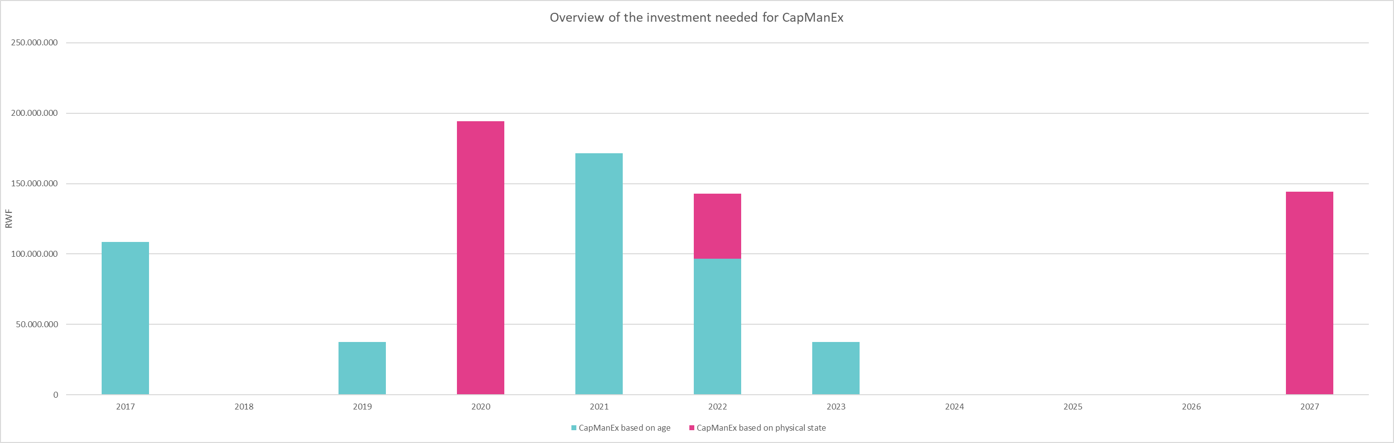

Figure 4: CapManEx cost based on the physical state of the component, spread over time based on the level of priority to repair or replace the components



Figure 5: Overview of CapManEx based on the physical state of the component spread over time depending on the level of priority to repair or replace the components

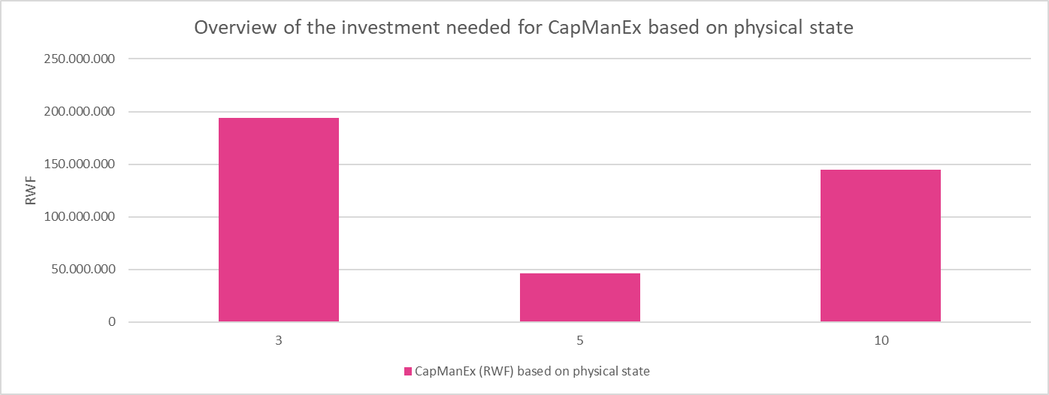

Figure 6: Overview of CapManEx based on the remaining life of the component

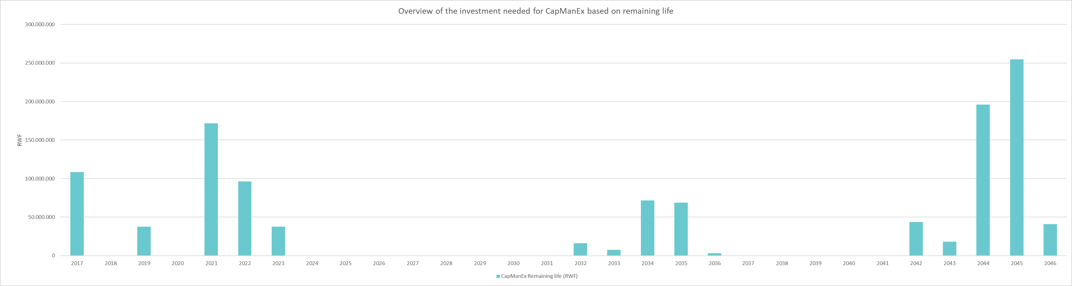



**CapManEx based on remaining life over years**

**CapManEx based on remaining life per scheme**

**CapManEx based on physical state per scheme**

**Total CapManEx of all schemes based on remaining life per year**

**Level of priority to replace/repair**

**Components needing CapManEx**

**Year of the construction/rehabiliation**

**Population using the scheme**

**Scheme name**

Figure 7: Summary table of CapManEx cost

# Annex 2: Bibliography

Boulenouar, J. Sanchez Trancõn Delia 2018. Guidance for developing a WASH investment plan.

Franceys, R. and Pezon, C., 2010. Services are forever: The importance of capital maintenance (CapManEx). (WASHCost Briefing Note 1b) [online] The Hague: IRC

International Water and Sanitation Centre.Available as pdf at: http://www.washcost.info/page/866 [Accessed 24 July 2018].

WaterforPeople, 2016. Asset analysis guidance for assessing piped-based water schemes

1. In the case of public tap even if the physical condition is “poor” or “does not function” it will always be the responsibility of the private operator to replace the asset component. Given that this CapManEx tool was designed for the district government in Rwanda, the cost of public tap are not taking into account by the tool.