Environmental Health Perspectives Volume 102, Number 3, March 1994
Research

Environmental Health Knowledge and Practice Survey among Secondary Schoolchildren in Zaria, Nigeria
R.D. Ebong
Department of Physical and Health Education, University of Uyo, Uyo, Akwa Ibom State, Nigeria, Africa
Abstract
Knowledge of environmental health was assessed in a sample of 192 students at Ja'afaru Secondary School, Zaria, Nigeria, by means of a questionnaire. A follow-up practice survey was also administered to assess the environmental sanitation of the school and the homes of a subsample of the students. Observations were recorded on the sources of water, the methods of refuse and sewage disposal, and the hygienic condition of the toilets in both the school and the homes surveyed. The findings indicated that the students' knowledge of environmental hygiene was high for all classes and that students whose fathers had primary, secondary, or post-secondary education scored slightly higher than those whose fathers were illiterate. Analysis of the observations on environmental sanitation showed that even though the school lacked indoor plumbing on the premises, the pupils were accustomed to pipe-borne and well water in their homes. The main method of refuse disposal for school and homes was open dumping, and the main method of sewage disposal for both school and homes was pit latrines, which were dirty and poorly maintained. Although the pupils had good knowledge of environmental hygiene, inadequate opportunities and lack of sanitation facilities at school and homes did not allow them to practice the health knowledge they had acquired. Recommendations were made to the school authority to direct more effort toward providing a safe and adequate water supply, good drainage systems, additional toilets, and renovating the existing toilets. The school should also emphasize the practice of good environmental hygiene to complement theoretical input. Key words: environmental hygiene, hygiene education, Nigeria, refuse disposal, sewage disposal, water supply. Environ Health Perspect 102:310-312(1994)
http://ehpnet1.niehs.nih.gov/docs/1994/102-3/ebong.html

I acknowledge with thanks the full cooperation of the principal and the teachers at Ja'afaru Secondary School and also the students who participated in the study. I appreciate the contribution of Abubakar Suleiman, senior community health assistant in the Department of Community Medicine in collecting the data. I also thank the parents of the students for their cooperation during the field survey. Finally, I thank F. O. Enahoro for her input.
Received 21 January 1993 ; accepted 3 January 1994.

Throughout the years and especially in recent times, environmental sanitation has been one of the major health concerns of developing countries. Environmental pollution is now increasingly recognized as a major threat to social and economic development and even to human survival (1). To focus attention on the need for hygienic surroundings and minimize the adverse effects of poor sanitation, particularly in most developing countries, the United Nations declared the years 1981-1990 as the International Drinking Water Supply and Sanitation Decade (2). Many countries have since adopted various strategies geared toward improving the environment.
The school education program emphasizes environmental health as one of its major components (3). The high prevalence of diarrhea and other communicable diseases among children of school age is due to the poor knowledge and practice of personal and environmental hygiene (4,5). The family is the basic unit of socialization, where learning first takes place. Therefore, home environmental sanitation should be assessed in the light of the knowledge provided at school. Relating home and school sanitation with the knowledge acquired at school will help highlight areas in which health behaviors require change. It will also pave the way for improving unsanitary environmental factors at home and at school that contribute to poor health and which people are ignorant about.
The objectives of the study were 1) to assess knowledge of environmental hygiene of a sample of secondary schoolchildren, 2) to assess the available sanitation facilities in the school and homes of a subsample, 3) to relate the students' knowledge to findings at school and home, and 4) to make necessary recommendations to the school authority based on findings of the study. The study was carried out between June and September 1989. A stratified random sample of 192 pupils at the Ja'afaru Secondary School, Zaria, Nigeria, was selected for the study (stratified in the sense that the researcher wanted to ensure that an appropriate number of elements were drawn from homogeneous subsets consisting of different classes of the population). Ja'afaru Secondary School was chosen because it cuts across rural and urban communities. It is a day secondary school, i.e., a nonboarding school that should provide a good forum for relating school and home practices with respect to environmental hygiene. This design also provided a small number of households for a home survey. The survey polulation included children in classes 3, 4, and 5. Children in classes 1, 2, and 6 were excluded from the study because children in classes 1 and 2 were not able to understand and give responses to questions during the pretesting of the questionnaire, and class 6 pupils were in their last term in the school, and this would have made follow-up impossible for subsequent phases of the study.
The study was carried out in two phases. In the first phase, a pretested questionnaire was administered by interview to the selected children. The information obtained included the following: 1) personal data: age, sex, present class in school, total years of schooling, and family size; 2) parental education and occupation; and 3) students' knowledge of environmental hygiene. This was assessed by asking five specific questions relating to environmental hygiene (see Table 5).
For the second phase, a stratified subsample of students was selected from the 192 students for a follow-up study to assess the environmental sanitation of the homes. However, data were only complete for 54 students. A separate questionnaire of three items was designed and used for this purpose. The data sought were source of water supply, methods used to dispose of waste water, refuse, and sewage, and hygienic condition of the toilet. This information was also obtained from the school. Data were compiled and analyzed specifically to evaluate the students' knowledge and relate this to the school and home environmental findings.
One mark was awarded for each correct answer, and the scores were converted to percentages for easy analysis. The scores were ranked as follows: one correct answer = 20%, two correct answers = 40%, three correct answers = 60%, four correct answers = 80%, five correct answers = 100%.
A total of 192 students, consisting of 101 (52.6%) males and 91 (47.4%) females, were surveyed in Ja'afaru Secondary School. Thirty-seven (19.3%) students were in class three, 84 (43.7%) were in class four, and 71 (37%) were in class five (Tables 1 and 2). Table 3 shows the educational status of parents: 28.6% fathers and 49.0% mothers were illiterate. Table 4 shows occupational status of parents, of which a majority, 61.5%, were skilled workers.
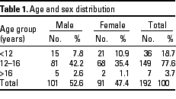
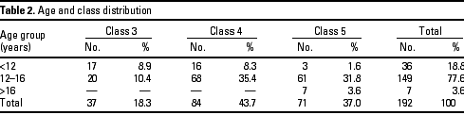
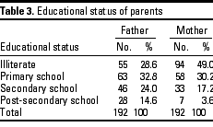
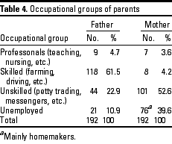
With respect to environmental hygiene, the percentage distribution shows that students had good knowledge of the subject. Most of them answered the questions correctly (Table 5).
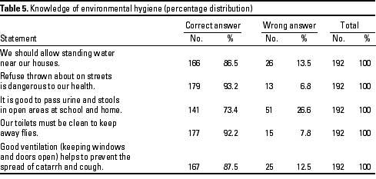
In regard to father's education, the results show that the literacy level of fathers had a slight, significant effect on students' responses to the questions. Students with literate fathers scored slightly higher than those with illiterate fathers (Table 6). Although 39 (20.3%) children whose fathers were illiterate got 100% of the questions correct, 88 (45.8%) children with literate fathers scored 100%.
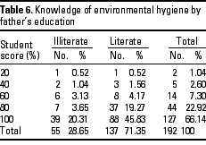
A subsample of 64 students made up of 34 (53.1%) males and 30 (46.9%) females were selected from the original sample of 192 students for a follow-up study of home environmental hygiene. Of this subsample, data were only available for 54 students, made up of 26 (48%) males and 28 (52%) females. Table 7 shows the age and sex distribution of subsample, and Table 8 shows the age and class distribution of the subsample. The subsample of 54 students was from households with family size ranging between 3 and 28.
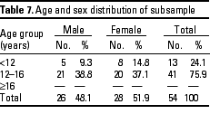
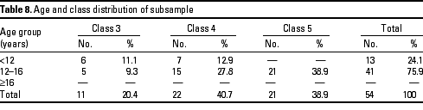
Environmental sanitation of the homes of the subsample and that of the school was assessed with respect to water supply, waste disposal (namely, sullage, refuse, and sewage), as well as the hygienic condition of toilets. Seventy-eight percent of the households surveyed had a functioning pipe-borne water supply; 22% of households obtained water from wells. None of the household respondents admitted obtaining water from streams and ponds.
With respect to the method of refuse disposal, 89.9% of households practiced open dumping of refuse. As to methods of sewage disposal, 70.1% of households used pit latrines, while 20.9% of households practiced indiscriminate disposal of feces. Of the 70.1% households that used pit latrines, 36% had toilets that were considered clean, whereas the remaining households had offensive toilets with numerous flies, feces around the toilets seat/slabs, and urine and waste papers on toilet floors.
Regarding the method of wastewater disposal (sullage), only 18 (33%) households had properly constructed drainage systems for wastewater, and 36 (67%) had open drainage systems.
On-site assessment of school sanitation revealed that there was no water supply in the school. Of the five pit latrines in the school, only one was fit for use, and this one was poorly maintained. There was no construction drainage in the school, and refuse was disposed of by open dumping.
This study indicated that all students surveyed were knowledgeable in environmental hygiene, but they lacked adequate opportunities either in the school or at home to practice what they knew. Students in lower classes scored lower than those in higher classes. Obviously, health knowledge grows as students progress from lower to higher classes. Generally, the high scores by students notwithstanding, the inadequate sanitation facilities in the school greatly undermined the goal of the knowledge instilled in the students. Although the environmental health knowledge scores where generally high, attention of the students should be drawn to areas of deficiency. Specifically, 51 (26.6%) students did not know that it is not good to urinate in open areas at school and home.
The results also showed that students with literate fathers scored slightly higher than those whose fathers were illiterate. Because the family is the basic unit of socialization where basic education first occurs before a child ever steps into school, it would be helpful for parents to know how to teach their children healthful practices, particularly by ensuring a sanitary environment for the family. It is therefore recommended that the Parent-Teacher Association (PTA) be used as a medium whereby teachers could enlighten the parents (especially the illiterate parents) on the importance of environmental hygiene.
The follow-up study indicated that 42 (78%) of the 54 households surveyed had a pipe-borne water supply and that the remaining 12 (22%) obtained water from wells. It is interesting to note that the school lacked any form of indoor plumbing, whereas the majority of the students were accustomed to some form of indoor plumbing in their homes. The school should therefore be encouraged to install some form of water supply for the students.
Only 18 (33%) of the households surveyed had properly constructed drainage, and there was no constructed drainage at all in the school. Open drainage, stagnant pools, and gutters have been observed around the school premises. The poor drainage of water in the school and in homes can encourage vector breeding, especially mosquitoes, which transmit malaria. The attention of the school authority has to be drawn to the importance, the need, and the usefulness of constructed drainage. The PTA should be used as a forum to enlighten parents on the need and usefulness of constructed drainage.
With regard to refuse disposal, the only method of refuse disposal at the school was open dumping, and that method was also used by most households. Open dumping should be discouraged. The school should find a better way of disposing of refuse, either by composting or burning. The PTA once again should be used as a forum where the teachers can enlighten parents on better methods of refuse disposal and their importance with regard to environmental sanitation.
The result also showed that most households used pit latrines, and they were not well kept. Indiscriminate defecation and urination around the school premises was commonly observed. The school had only one pit latrine, which was not well kept. The school should therefore be informed about the importance and the need to have more pit latrines with covers, kept clean and free from odor. Through the PTA, parents should be made aware of the importance of providing well kept, clean toilets for their households. Students should also be encouraged about the need to use the provided toilets and should also be informed about the ill effects of indiscriminate defecation and urination around the home and school premises.
In conclusion, the Ja'afaru Secondary School needs a lot of health education to come up to an "average" standard of environmental sanitation. The molding of children begins at home and ends in school. If the school does not match environmental heath knowledge instilled in the children with practical examples, and the parents are ignorant about the effects of poor environmental heath practices, then the ill effects will be on the children. Therefore, the school should play a large part in trying to assess and modify the poor environmental health practices, and the teachers should help educate parents through the PTA on how to gear their children toward good environmental health practices or habits.
Recommendations were made to the school authority to direct more effort toward the provision of a safe and adequate water supply, good drainage systems, additional toilets, and renovation of the existing toilets. The school should also emphasize good practice of environmental hygiene to complement theoretical input. It was suggested that the PTA be reactivated and used to educate parents on the need for proper environmental hygiene practices.

References
1. World Health Organization. Expert Committee. Problems of the human environment. WHO Chronicle 27(7-8):325-327 (1973).
2. World Health Organization. Promoting environmental health in the years 1978-1983. WHO Chronicle 33:169-173(1979).
3. Hanlon JJ. School and adolescence health. In: Public health administration and practice. London:C.V. Mosby, 1979;4-84.
4. Koopman JS. Diarrhea and school toilet hygiene in Columbia. Am J Epidemiol 107:412-420(1978).
5. Oduntan SO. The health of Nigerian children school age III. Ann Trop Med Parasitol 68:157-165(1974).

