Accra, Ghana, 10-12 November 2009

West Africa Regional Sanitation and Hygiene Symposium

Strengthening local capacities in watsan in Diang chiefdom in Sierra Leona.

Spain, García de Francisco A., Salvadori M. & Sesay A.

Abstract: Médicos del Mundo (MdM) is an International NGO who is working in Port Loko and Koinadugu District in Sierra Leone since 2001, developing Primary Health and Water and Sanitation Activities. Diang is one of the most remote and isolate Chiefdom of Koinadugu District, in the border with Guinea, within 78 communities and 2.486 houses, covering a population of 34.860 habitants. The safe sanitation access coverage is 10% and 8% respectively in Koinadugu District and in Diang Chiefdom. During the last six months, MdM has carried out activities of Community Led Total Sanitation (CLTS) in Diang Chiefdom. This methodology mobilizes communities to achieve the complete elimination of open defecation (OD), focusing on the Community behavioural change to promote the construction of their own latrines in order to declare “open defecation-free” villages (ODFV).
MdM has facilitated the Communities to conduct their own appraisal and analysis of OD, creating 78 Health Committees and training 269 Health Motivators and 429 Community members in CLTS methodology in order to spread a low cost sanitation system in those communities.
Three months after the intervention, 62% of the Communities have achieved to be decelerated as ODFV and 1.342 latrines were constructed. The total cost of this intervention was 3.000 $.
Conclusion: CLTS is a successful intervention in rural areas in which sanitation coverage is very low, the budget is nonexistent and it is necessary a quick spread of these services.

Introduction:
Médicos del Mundo – Spain (MdM-S) (Doctors of the World) is an independent non-profitable organization that works with local health authorities and communities in the development of health capacities and the defence of human rights. Since April 2001, Médicos del Mundo is working in partnership with the Ministry of Health of Sierra Leona, in the development of Primary Health Care in the Districts of Port Loko and Koinadugu.
Sanitation conditions in Sierra Leona are one of the worst in the World: only 22% of people have access to safe water and 15% access to sanitation¹. These deficiencies are even worse in Koinadugu District and Diang Chiefdom, where access to sanitation is 10% and 8% respectively.
UNICEF is the leading agency for the implementation of the Millennium Goals for water and sanitation in Sierra Leona, and holds monthly meetings with NGOs and other actors working in rural and local development. According to UNICEF, in Sierra Leona there are approximately 30,000 latrines, and estimates that 300,000 are needed in order to achieve the Millennium Goals; which means that 50,000 should be built every year until 2015. Considering the high cost of Ventilated Improved Pit latrine, UNICEF introduced the Community Led Total Sanitation² (CLTS) as a feasible alternative, and encouraged NGOs and other development actors to implement CLTS in their respective projects.
CLTS approach has been used successfully in South East Asia and East Africa³. Using Participatory Rural Appraisal methods, it enables local communities to analyse their sanitation conditions, collectively internalise the need to stop open air defecation and build their own latrines without external subsides.
Medicos del Mundo has been using the CLTS approach to improve the sanitation conditions in Diang since 2008. We present here the first results of this experience.

Activities
The project started in December 2008 establishing contact with all communities of the Chiefdom of Diang and selecting all those that matched the criteria stated in the CLTS manual by Kar & Chambers (table 1).

Table 1. Criteria for selecting communities for CLTS methods
More favourable Community criteria
Small settlement (hamlet rather than big village) | Unprotected vulnerable and currently polluted water supplies, as in some mountainous areas
Wet/moist conditions which wash excreta around and keep it smelly and nasty | No current, previous, nearby or national programme of hardware subsidies to households
Socially and culturally homogeneous | Visibly filthy conditions. Stable soil and easy to dig
Lack of cover in the surrounding area | Young and progressive local leadership
Remoter rather than closer to towns and big roads | Existence of active groups within the community

A total of 78 villages adding up 2,483 households where identified, and all were invited to participate. The number of beneficiaries was 34,860 people (table 2).

Table 2. Beneficiaries
Chiefdom Name | Nº of Villages | Population | Age <1 year | Age <5 years
Foria | 21 | 9.593 | 384 | 1.631
Yaráh | 13 | 3480 | 139 | 592
Kania | 22 | 5.373 | 215 | 913
Kondembayá | 10 | 9.760 | 422 | 1.795
Lengekoro | 9 | 5.854 | 234 | 995
TOTAL | 75 | 34.860 | 1.394 | 5.926

Before starting activities, a complete mapping of existing latrines was done in January 2009, recording location, year of construction, type, state of use, etc).
Using participatory techniques and focal groups, every village established a health committee in charge of stimulating and educating the community in the care of its own health and in charge of the follow up of the CLTS activities and progress. The health committees were formed with MdM personnel and relevant members of the community selected by the Village Central Committee (traditional village leaders) among those who matched the following conditions:
- Could read and write
- Natural leadership
- Capable of social mobilization
- Motivated with community health care.

During February 2009, health committees were trained in CLTS methods selecting an average of three health motivators in every village to implement the CLTS activities. An agreement was signed with the Village Central Committees with the commitment of building the latrines in one month. During March and April 2009, each village built their latrines using CLTS methods. Experts in water and sanitation from MdM supervised the construction of latrines, and carried out a survey during May and June in order to declare “open defecation free villages”.

Results
The mapping of existing latrines in the Chiefdom of Diang showed 591 latrines. Only 37% were complete and in use; the rest were unfinished or useless.
Health committees were created in each of the 78 villages, with 429 members trained in CLTS methods. Training in community health motivation was given to 269, an average of three in every village.
Of the 78 villages identified, 75 villages participated in the construction of latrines of CLTS type, building 1,342 family latrines. The average construction time was 33,7 days. At the end of the stipulated building time (one month), 60% of latrines were complete (slabing, fence and roof). To build their latrines, each family used the local materials they thought best: mud, palm leaves, branches, etc. (Photograph 1,2).

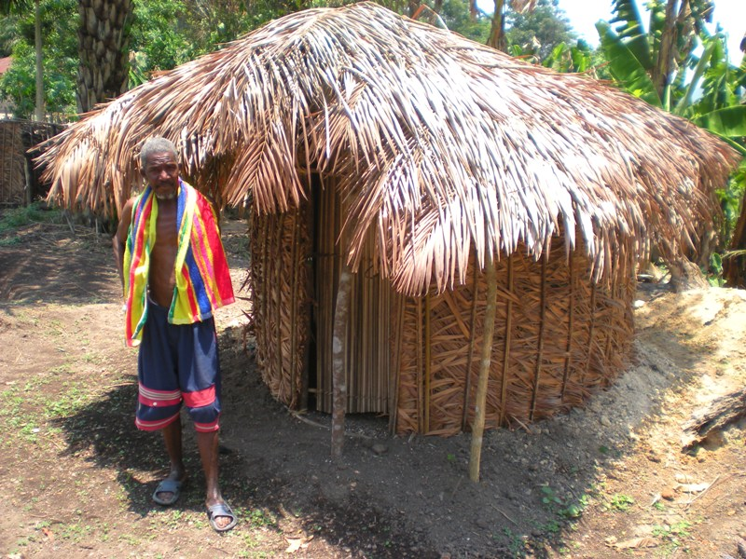 |  | 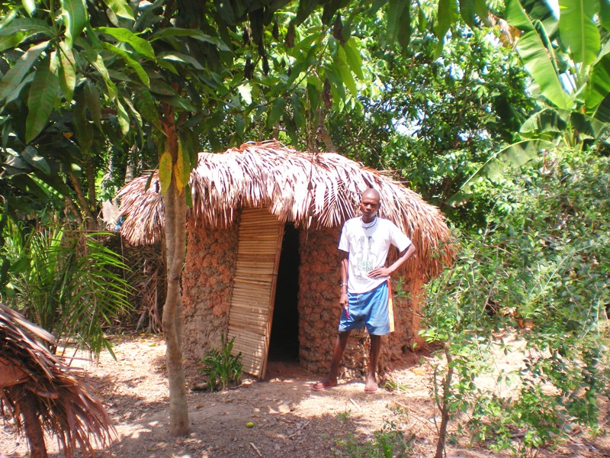
Photograph 1. CLTS latrine in Foria Catchment in Diang Chiefdom |  | Photograph 2. CLTS latrine in Legenkoro Catchment in Diang Chiefdom

By the end of June 60% of villages could be declared ODF (fig. 1), and 62% of people had access to sanitation in the Chiefdom of Diang (fig. 2).

Figure 1. CLTS outcomes in Diang |  | Figure 2. Coverage in Sanitation Facilities in Sierra Leone

The total cost of the project was USD 3,000, of which USD 1,712 was used in training health committees and health motivators, and USD 1,298 in supervising the process.

Discussion
Open Air Defecation is a major public health problem in rural areas of Sierra Leona. Building ventilated improved pit latrines for all, needs large inputs of external subsides, and does not solve the problem of use and maintenance.
The use of CLTS methodology in the Chiefdom of Diang has shown promising successful results. Following the example of Cambodia and Bangladesh ^{3,4,} with only hands-off approach by external facilitators, it empowers communities to change their sanitation conditions easily and fast. People should be motivated to build their own latrines, and above all, should interiorise the need to use them and maintain them. Only through the enthusiastic compromise local health authorities and especially of local leaders can this be achieved.
Not all communities respond in the same way. Some are more enthusiastic with the idea, while others are moved only when they hear and see what their neighbours have done. The problems we encountered were in identifying natural leaders, how to handle bigger villages and how to manage a follow up schedule in the very remote areas with difficult access.
The great challenge for the future is, if the communities will be able to maintain the sanitation structures, with the adverse climate conditions that will probably deteriorate them rapidly, or will allow people to go back to open air defecation.

Acknowledgements
The author/s would like to extend thanks to all the all the people who are involved in this project, specially to Mummies Queen and Paramount Chief of Diang Chiefdom, who had mobilized their communities and the Ministry of Health and Sanitation representative in Koinadugu District, Dr. Kargbo and his team.
References
Water Supply and Sanitation Policy for Sierra Leona 2007. United Nation Economic Commission for Africa (2007). Available at http://www.daco-sl.org/encyclopedia/4_strat/4_2f_w.htm (Accessed 9 August 2009).

Karl, K; Chambers, R (2008). Handbook on Community-Led Total Sanitation. Brighton Sussex, BN1 9RE. England. Institute of Development Studies. Available at http://www.communityledtotalsanitation.org/page/clts-approach (Accessed 9 August 2009).

Karl, K; Bongartz, P (2006). Update of some recent developments in Community-Led Total Sanitation. Brighton Sussex, BN1 9RE. England. Institute of Development Studies. Available at http://www.communityledtotalsanitation.org/page/clts-approach (Accessed 9 August 2009).

Sannan, D; Moulik, SG. (2007). Community-Led Total Sanitation in Rural Areas. An Approach that Works. Water and Sanitation Program- South Asia. The World Bank . New Delhi. India. Available at http://esa.un.org/iys/docs/san_lib_docs/WSP-Community%20Led.pdf (Accessed 10 August 2009).

Keywords
Community, Koinadugu, Sanitation, Latrine, watsan.

Contact details

Name of Principal Author: Ana García de Francisco  Address: 2 Man of war bay. Aberdeen. Freetown. Sierra Leona  Tel: 0023276747937  Fax:  Email: sierraleonamedicosdelmundo@gmail.com  www: medicosdelmundo.org | Name of Second Author: Massimo Salvadori  Address: 2 Man of war bay. Aberdeen. Freetown. Sierra Leona  Tel: 00232769007300  Fax:  Email: sierraleonamedicosdelmundo@gmail.com  www: medicosdelmundo.org

