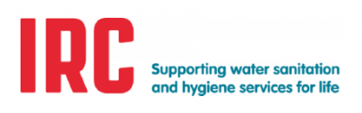
She Makes Change sponsor form
My name is ______ and I am raising money for women’s empowerment workshops in Odisha, India. IRC works with local women to give them the knowledge and skills needed to increase their participation in decision making and local government. This results in better water, sanitation and hygiene management and better services for the whole community.
Please donate to IRC’s campaign aiming to raise €2,500 to facilitate 3 one day workshops for these women.
Full name | Email | Amount donated | Date

How to pay in
1. Online: deposit all cash donations into your bank account and donate the funds on the IRC website donation page: [insert QR code]
2. Deposit cash to IRC’s bank account NL37ABNA0514218428 and make sure to reference ‘SHE MAKES CHANGE’ so we know what your donation is for 😊

